UDC 519.6

V.V. Komyak, V.M. Komyak, A.V.Pankratov, A.Yu.Prikhodko

Obtaining Local Extremum in the Problem of Covering the Fields by the Circles of Variable Radius

Keywords: circle of variable radius coverage, coverage criteria, optimization, nonlinear programming

Formulation of the problem. In various industries of the economy there are problems associated with the processing and transformation of geometric information. These problems are referred to a class of optimization geometric design problems [1], which solution as well as the development of their methods is important. This class of problems include the problem of optimal material cutting (both regular and irregular), the problems of building the optimal ways and linking networks, coverage, partition, some scheduling problems, and others. [1 - 2].
Analysis of publications. An important class of geometric design problems are problems of irregular covering the field by geometric objects [3], as well as regular [3 - 7]. In the problems of covering it is set up a claim that all points of the field were covered by geometric objects, while the conditions of non-intersection of objects between themselves and their placement in the field may be violated. Results and detailed reviews on given researches are in [8 - 10]. The problems of single covering a limited area by N-circles (such as in a Euclidean metric, and in some other metrics) is also known as the problem of N-centers. For the problem of N-centers in different metrics it is offered a variety of heuristics and algorithms using Voronoy’s regions [11]. Problems of coverage are models of many practical problems. In [12] it is set and solved the problem of interaction between militarized security subdivisions of the railroad and fire-rescue units, which is reduced to covering the area by the circles of different radii. In [13] it is set the problem of the placement optimization for observation points, which arises when designing ground video monitoring systems. The problem is reduced to the problem of covering the area by the circles of variable radii, the value of which depends on the class of fire danger of covered area and its relief. Thus, the important practical problems require to develop the methods of covering the fields by circles of variable radius.
In our article, we propose an approach to obtaining a local extremum of covering problem.

Setting the problem. There is a polygon $P$, defined by a set of vertices $p$, $k=1,2,\text{.}\text{.}\text{.},n$ and a set of circles $C_{i}$, $i=1,2,\text{.}\text{.}\text{.},N$, with varying radius $r_{i}<r$ and centers $v_{i}=(x_{i},y_{i})\text{.}$
Suppose $u=(v_{1},r_{1},\text{.}\text{.}\text{.},v_{N},r_{N})$ – vector of variables, $F(u)$ - the objective function (for example, the total area of the circles $π\sum_{i=1}^{N}{r_{i}^{2}})$, $Ξ(u)=\underset{i=1}{\overset{N}{}}C_{i}(u_{i},r_{i})$.
By definition $Ξ(u)$ – coverage of polygon $P$ if $P⊂Ξ(u)⇔Ξ^{'}(u)intersectP=∅$, where $Ξ^{'}(u)=R^{2}\text{\backslash int}Ξ(u)$.
Note 1. In this study, we consider only such coverings, which met the following conditions $\text{int}C_{i}⊄Ξ_{i}(u)$, $Ξ_{i}(u)=\underset{j=1}{\overset{i−1}{}}C_{j}(v_{j},r_{j})\underset{k=i+1}{\overset{N}{∪}}C_{k}(v_{k},r_{k})$ and $\text{int}C_{i}(v_{i},r_{i})intersect\text{int}P≠∅$, $i=1,2,\text{.}\text{.}\text{.},N$.
Problem of circular coverage of polygon. The start point – vector $u^{0}=(v_{1}^{0},r_{1}^{0},\text{.}\text{.}\text{.},v_{N}^{0},r_{N}^{0})$, where $Ξ(u^{0})$ covers a polygon $P$. The task – to determine the vector $u^{}=(v_{1}^{},r_{1}^{},\text{.}\text{.}\text{.},v_{N}^{},r_{N}^{})$, in which $F(u)$ reaches the extreme and $Ξ(u^{})$ is coverage of a polygon $P$.
The problem of covering polygon by circles. Mathematical model of the problem of circular coverage can be represented as follows:
$\underset{u∈W}{\text{extr}}F(u)$, (1)
where
$W=\left\{u∈R^{3N}:Ξ^{'}(u)intersectP=∅\right\}$. (2)

As a criterion of covering for a fixed $u$ can be used phi-function method[14]:
,
where – phi-function of objects $Ξ^{'}(u)$ and $P$ [14].
Since the description of admitted region of the form (2) in an analytical form is extremely difficult theoretical problem and requires significant computational cost, in this study we propose the coverage criteria based on the following statement.
We say that a relative position of the circle $C$ and the points $p∈\text{frP}$ satisfies the condition 1, if $p∈C$ and for any arbitrarily small $ε>0$ in $ε$-neighborhood of the point $p$ there is a point $p^{'}$ such that $p^{'}∈\text{frP}$ and $p^{'}∈C$. Here $\text{frP}$ – the boundary of the set $P$ (Figure 1.).

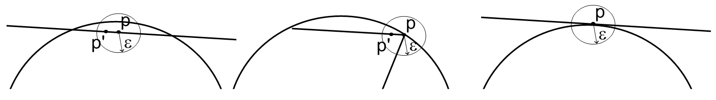
а) b) c)
Figure 1. a) and b) – the relative position of the point and the circle satisfies the condition 1; c) - the relative position of the point and the circle does not satisfy the condition 1.

We say that the relative position of the intersection point $t$ of circle $C_{1}$ and $C_{2}$with the centers in the points $v_{1}$ and $v_{2}$ radius $r_{1}$ and $r_{2}$ with the circle $C$ satisfies condition 2, if $t∈C$ and there is a positive number $δ$ such that for any arbitrarily small strictly positive $ε<δ$ intersection point $t^{'}$ of circles $C_{1}^{'}$ and $C_{2}^{'}$ and radius $r_{1}+ε$ and $r_{2}+ε$ with centers in points $v_{1}$ and $v_{2}$ also belongs to the circle $C$ (Figure 2).

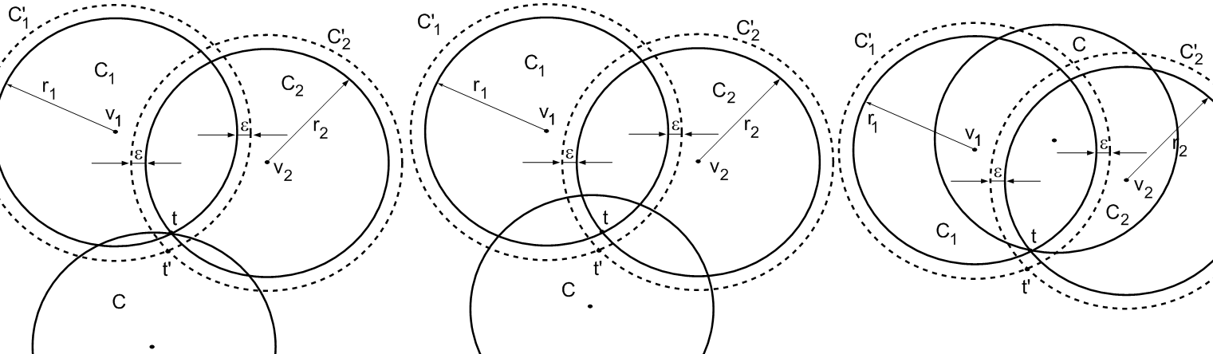
а) b) c)
Figure 2. a) and b) - the relative position of the point and the circle satisfies condition 2; c) - the relative position of the point and the circle does not satisfy condition 2.

Note that if $t∈\text{int}C$, the relative position of the point of intersection $t$ and the circle $C$ satisfies the second condition.
Statement. In order $Ξ(u)$ to cover the polygon $P$, it is necessary and sufficient that the vector $u=(v_{1},r_{1},\text{.}\text{.}\text{.},v_{N},r_{N})$ satisfies the condition:
1) for each vertex $p_{k}$ of the polygon $P$ there is at least one circle $C_{i}$ such that their relative position satisfies the first condition (Figure 3);
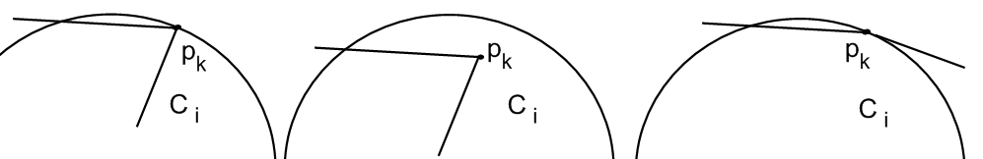

а) b) c)
Figure 3. Three types of the relative position of the vertex of the field and the circle, which satisfy the first item.

2) for any point $t∈{\text{frC}}_{i}intersect\text{frP}$, the relative position with the circle $C_{i}$ satisfies the first condition, there is a circle $C_{j},i≠j$, which the relative position of the point also satisfies the first condition (Figure 4);

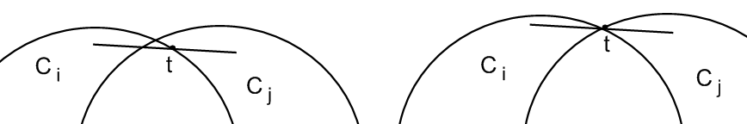

Figure 4. Two types of relative position of the intersection point of the circle with the field and the circle for the item 2).

3) for each point $t={\text{frC}}_{i}intersect{\text{frC}}_{j}$, $t∈\text{frP}$ exists $C_{s},s≠i,s≠j$, such that the relative position of the point $t$ and the circle $C_{s}$ satisfies the second condition (Figure 5);

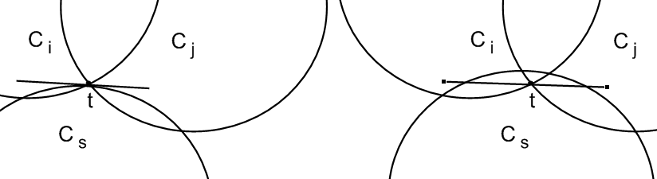
Figure 5. Two types of relative position of the intersection point of circles and the circle for the item 3).

4) for each point $t_{q}={\text{frC}}_{i}intersect{\text{frC}}_{j}$, $t_{q}$, $q=1,2$ $i≠j$, there are $C_{s},s≠i,s≠j$, such that the relative position and $C_{s}$ satisfies the second condition (Figure 6).
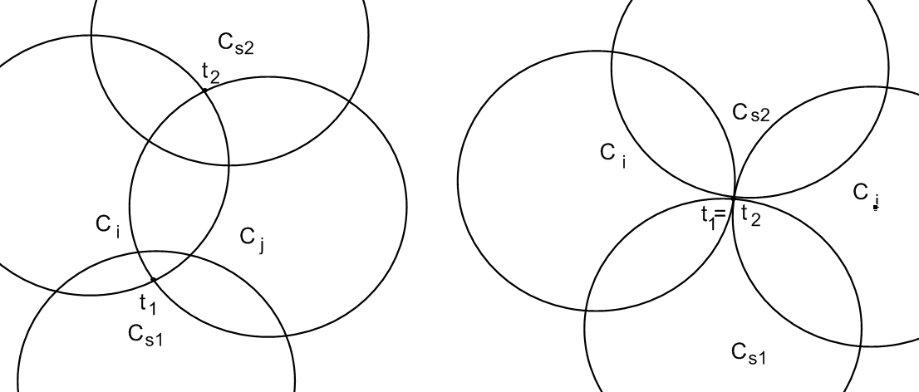
а) б)
Figure 6. Two types of relative position of the intersection point of circles and the circles for the item 4).

Note 2. Further when forming set of constraints for the problem to item 4, we do not take into account two circles for which both points $t_{q}$, $q=1,2$, belong to inner part of the circle $C_{s}$, since taking into account these conditions appear to be excessive.
Note 3. It is assumed that for item 4 the points $t_{q}$, $q=1,2$ are different and even in the case of their superposition (circles $C_{i}$ and $C_{j}$ are contiguous) each of them belongs to its circle (Figure 6b).
Items 1 – 4 can be rewritten in the equivalent form
1) $∀p_{k}$$k∈I_{n}$, exists such circle $C_{i}$, that $p_{k}∈C_{i}$, $C_{i}⊄P$.
2) If there is a point $t∈{\text{frC}}_{i}intersect\text{frP}$, $C_{i}⊄P$, then there are a circle $C_{j}$ and a point $v_{\text{ij}},i≠j$, such that $v_{\text{ij}}∈C_{i}$, $v_{\text{ij}}∈C_{j}$, $v_{\text{ij}}∈R^{2}\text{\backslash int}P$;
3) if there is a point $t={\text{frC}}_{i}intersect{\text{frC}}_{j}$ and wherein $t∈\text{frP}$, there is $C_{s}$ and a point $v_{\text{ijs}},s≠i,s≠j$, such that $v_{\text{ijs}}∈C_{i}$, $v_{\text{ijs}}∈C_{j}$,$v_{\text{ijs}}∈C_{s}$;
4) If there is a point $t_{q}={\text{frC}}_{i}intersect{\text{frC}}_{j}$ and $t_{q}∈\text{int}P$, $q=1,2$,$i≠j$, then there is a circle $C_{s}$ and a point , such, that , ,.
On the figure 7 there is an example of a polygon coverage by the set of circles with the points of type $v_{\text{ij}},v_{\text{ijs}},v_{\text{ijs}1},v_{\text{ijs}2}$.
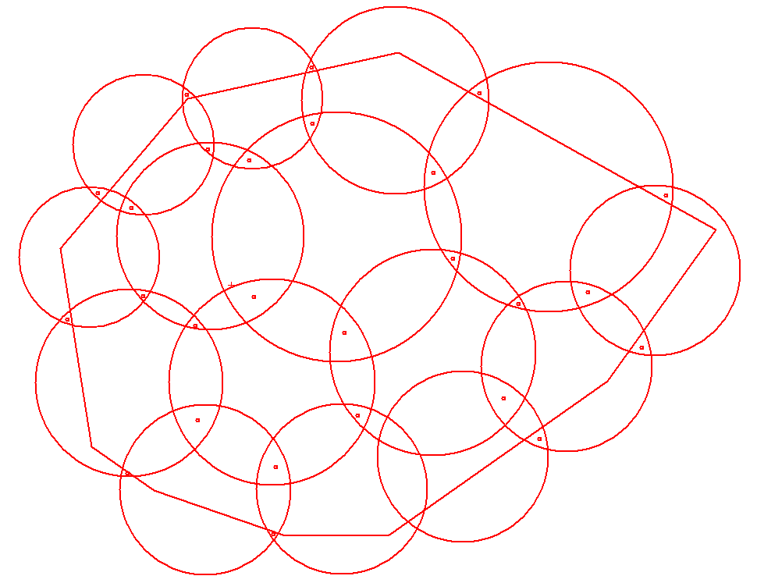

Figure 7. Example of coverage by circles with system of auxiliary points.

With this in mind, the inequalities describing the admitted region of the problem based on the information about the start point can be written as:
1) for the vertices of the polygon $∀p_{k}$$k∈I_{n}$, and the corresponding circles $C_{i}$, $p_{k}∈C_{i}$, $C_{i}⊄P$, inequality:

, (3)

2) for points $t∈{\text{frC}}_{i}intersect\text{frP}$, circles $C_{i}⊄P$ and the corresponding circles $C_{j}$ – the inequalities system in the form

$\begin{aligned}\left\{(x_{i}−x_{\text{ij}})^{2}+(y_{i}−y_{\text{ij}})^{2}≤r_{i}^{2}; | \right.\left\{(x_{j}−x_{\text{ij}})^{2}+(y_{j}−y_{\text{ij}})^{2}≤r_{j}^{2}; | \right.\end{aligned}$ (4)

where $f_{\text{ij}}(x_{\text{ij}},y_{\text{ij}})≥0$ – the membership function of the set $R^{2}\text{\backslash int}P$of points $v_{\text{ij}}$ (maximum of $k$ linear functions);
3) for points $t={\text{frC}}_{i}intersect{\text{frC}}_{j}$, $t∈\text{frP}$ and the corresponding circles $C_{s}$– the inequalities system in the form

$\begin{aligned}\left\{(x_{i}−x_{\text{ijs}})^{2}+(y_{i}−y_{\text{ijs}})^{2}≤r_{i}^{2}; | \right.\left\{(x_{j}−x_{\text{ijs}})^{2}+(y_{j}−y_{\text{ijs}})^{2}≤r_{j}^{2}; | \right.\end{aligned}$ (5)
4) for points $t_{q}={\text{frC}}_{i}intersect{\text{frC}}_{j}$ and $t_{q}∈\text{int}P$, $q=1,2$,$i≠j$ and the corresponding circles – the inequalities system in the form:

$\begin{aligned}\left\{(x_{i}−x_{\text{ijs}1})^{2}+(y_{i}−y_{\text{ijs}1})^{2}≤r_{i}^{2}; | \right.\left\{(x_{j}−x_{\text{ijs}1})^{2}+(y_{j}−y_{\text{ijs}1})^{2}≤r_{j}^{2}; | \right.\left\{(x_{s1}−x_{\text{ijs}1})^{2}+(y_{s1}−y_{\text{ijs}1})^{2}≤r_{s1}^{2}; | \right.\end{aligned}$ (6)

where $f(x_{\text{ijsq}},y_{\text{ijsq}})<0$ – membership function of the point $v_{\text{ijsq}},q=1,2$ set $P$
and
$\begin{aligned}\left\{(x_{i}−x_{\text{ijs}2})^{2}+(y_{i}−y_{\text{ijs}2})^{2}≤r_{i}^{2}; | \right.\left\{(x_{j}−x_{\text{ijs}2})^{2}+(y_{j}−y_{\text{ijs}2})^{2}≤r_{j}^{2}; | \right.\left\{(x_{s1}−x_{\text{ijs}2})^{2}+(y_{s1}−y_{\text{ijs}2})^{2}≤r_{s1}^{2}; | \right.\end{aligned}$ (7)

It is necessary to find an extremum of the given objective function at admitted region $W$, given by constraints systems in the form (3) – (7).
The problem belongs to nonsmooth optimization problems due to the presence of non-smooth functions belonging to the type $f_{\text{ij}}(x_{\text{ij}},y_{\text{ij}})≥0$ (4) and $f(x_{\text{ijsq}},y_{\text{ijsq}})<0$ in (6) and (7). Admitted region can be divided into sub-areas, described by inequality systems with smooth functions. Thus, the solution of the problem can be reduced to solving a sequence of problems of nonlinear programming. As the objective function can be chosen arbitrary smooth function, including: minimizing the radii of the covering circles, minimizing the number of circles (if it is possible to reduce one of the radii down to zero) and reliability (maximization areas of overlap).
Figure 8 – 13 shows examples of test problems of covering a circle by the circles, where local optimization was produced from the obtained points with different objective functions.
Conclusions. The constructed model of covering the polygon by the circles of variable radii and a method for obtaining local extremum is basic for a wide range of practical problems, in particular for the problem of locating points of video surveillance, which arises when designing ground video monitoring systems.

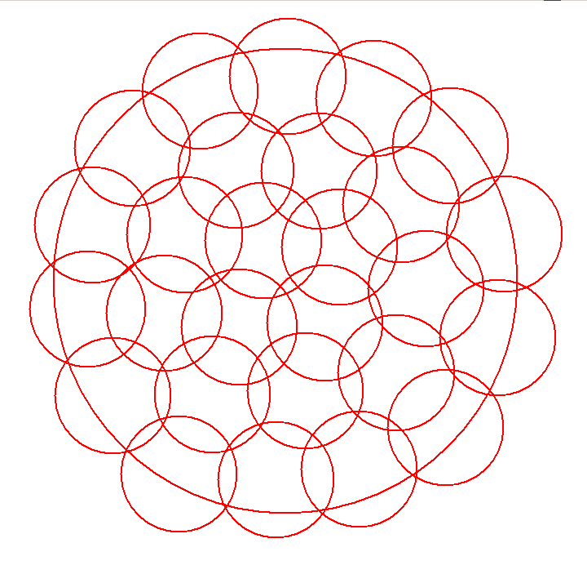 |  | 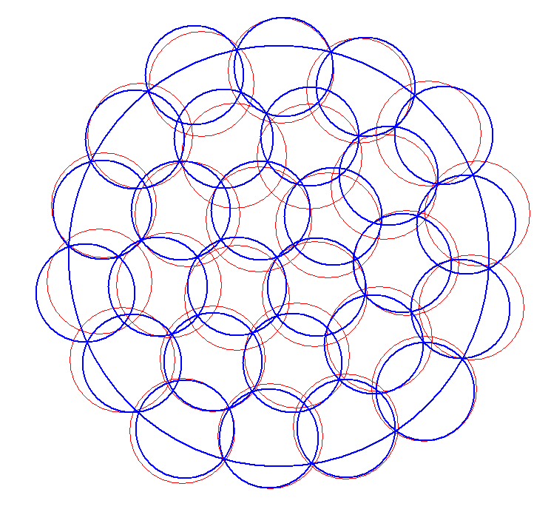
Figure 8. Original cover (produced by hand) of the field with radius 4, covering 27 circles, radii of the circles is 1. | Figure 9. Local extremum with objective function - the minimization of the maximum radius of the covering circles. Time of calculating 0.09 s., the radius is 0.941.
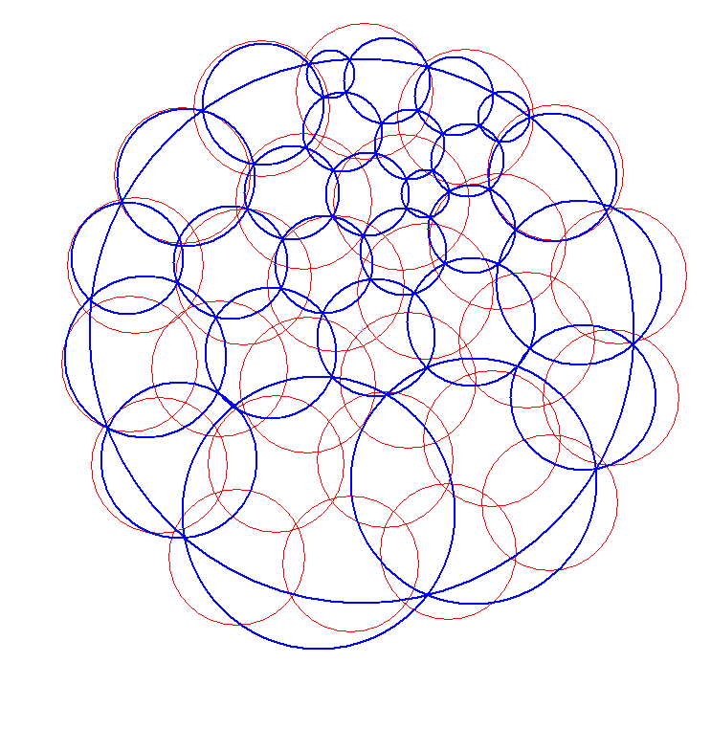 |  | 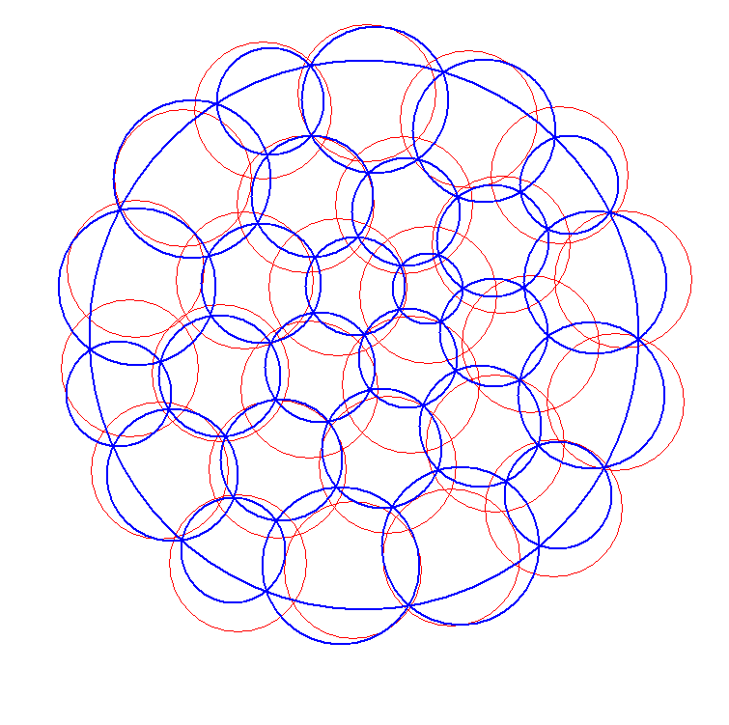
Figure 10. Local extremum with objective function – the minimization of the radii sum of the covering circles. Time of calculating is 0.125 s., the sum is equal to 22,942. |  | Figure 11. Local extremum with objective function – the minimization of the squares of the radii sum for the covering circles. Time of calculating is 0.047 s., the sum of the radii squares is 22.106.
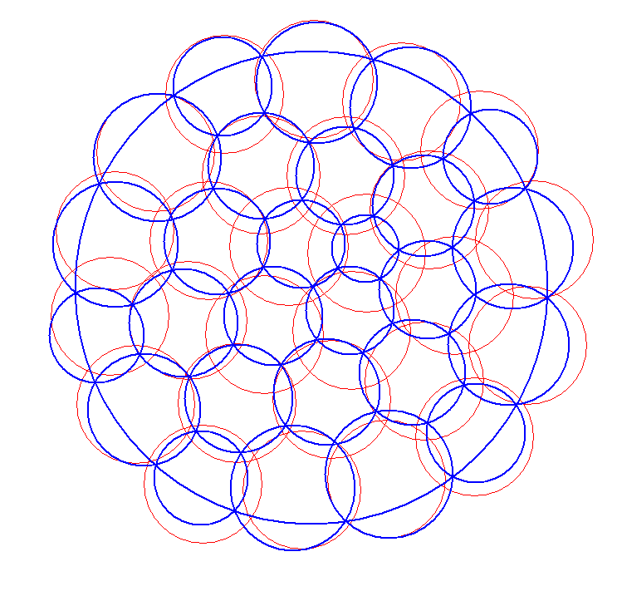 |  | 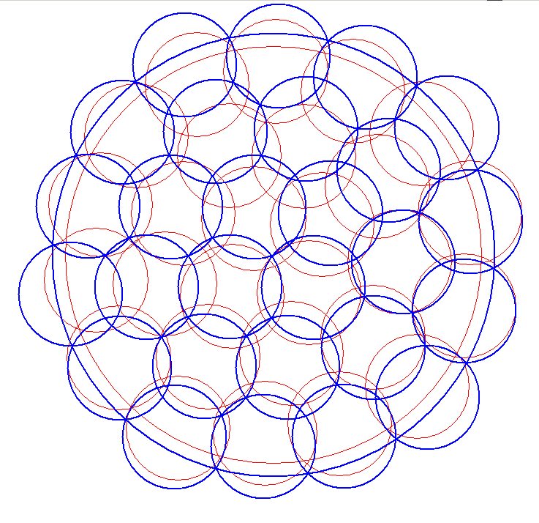
Figure 12. Local extremum with objective function - the minimization of the cubes of the radii sum for the covering circles. Time of calculating is 0.062 s., the sum of cubic radii is equal to 20,693. |  | Figure 13. Local extremum with objective function – maximizing the radius of the field at the fixed radii of the circles. Time of calculating is 0.093 s., radius of the field is 4.251.
REFERENCES

- Стоян Ю.Г. Основная задача геометрического проектирования / Ю.Г. Стоян. – Х.: Ин-т проблем машиностроения АН УССР – 1983. – 36 с. (Препринт/ АН УССР. Ин-т проблем машиностроения; 181.)
- Элементы теории геометрического проектирования / [Яковлев С.В., Гиль Н.И., Комяк В.М. и др.]; под ред. В.Л. Рвачева. – К.: Наук. думка, 1995. – 241 с.
- Стоян Ю.Г. Математические модели и оптимизационные методы геометрического проектирования / Ю.Г. Стоян, С.В. Яковлев. – К.: Наук. думка, 1986. – 265 с.
- Романова Т.Е. Метод покрытия прямоугольника конгруэнтными кругами с учётом дополнительных ограничений / Т.Е. Романова, А.В. Панкратов, В.Н. Пацук, С.Б. Шеховцов // Радиоэлектроника и информатика. – 2005. – № 1. – С. 48-51.
- Антошкин А.А. Задача покрытия прямоугольной области кругами заданного радиуса / А.А. Антошкин, А.В. Панкратов, В.Н. Пацук та ін. // Радиоэлектроника и информатика. – 2001. – № 3. – С. 38 - 41.
- Панкратов А.В. Метод регулярного покрытия прямоугольной области кругами заданного радиуса / А.В. Панкратов, В.Н. Пацук, Т.Е. Романова, А.А. Антошин // Радиоэлектроника и информатика. – 2002. –№ 1. – С. 50 - 52.
- Злотник М.В. Стратегия решения задачи покрытия многосвязной многоугольной области / М.В. Злотник, А.В. Кривуля, А.В. Панкратов, Т.Е. Романова // Бионика интеллекта. – 2007. – 2(67). – С. 51–55.
- Фейеш Тот Л. Расположения на плоскости, на сфере и в пространстве / Фейеш Тот Л. – М.: Физматгиз. – 1958. – 363с.
- Fejes Tot G. Multiple packing and covering of spheres / Fejes Tot G. // Acta Math. Acad. Sci. – Hungar. – 1979. – V.34. – №1 – 2. – P. 165 – 176.
- Конвей Дж. Упаковка шаров, решетки и группы / Дж.Конвей, Н. Слоен. – М.: Мир. – 1990. – Т. 1– 2.
- Drezer Z. The p-centre problem – heuristic and optimal algorithms / Z. Drezer // J.OR Soc. – 1984. – V.35. – P.741-748.
- Собина В.О. Особливості методу визначення раціональної кількості та місць розташування оперативних підрозділів для захисту об’єктів залізниці / В.М. Комяк, О.М. Соболь, А.Г. Коссе, В.О. Собина // Проблеми надзвичайних ситуацій. Зб. наук. пр. НУЦЗ України. – Харків: НУЦЗУ, 2010. – Вип.11. – С. 74-79.
- Комяк В.М. Оптимизация размещения пунктов наблюдения наземних систем видео-мониторинга лесных пожаров / В.М. Комяк, А.В.Панкратов, А.Ю. Приходько, С.Д. Светличная // Проблемы пожарной безопасности. Сб. науч. тр. НУГЗ Украины. – Харков: НУГЗУ, 2014. – Вып.36. – С. 117-126.
- Стоян Ю.Г. Полный класс Ф-функций для базовых объектов / Ю.Г. Стоян, Т.Е. Романова, Н.И. Чернов, А.В. Панкратов // Доп. НАН України. – 2010. – № 12. – C. 25-30.

